**POC 2: Remove the default behavior of a visual (Table Visual) in Power BI**

Step 1: Add 2 blank tables in the report.

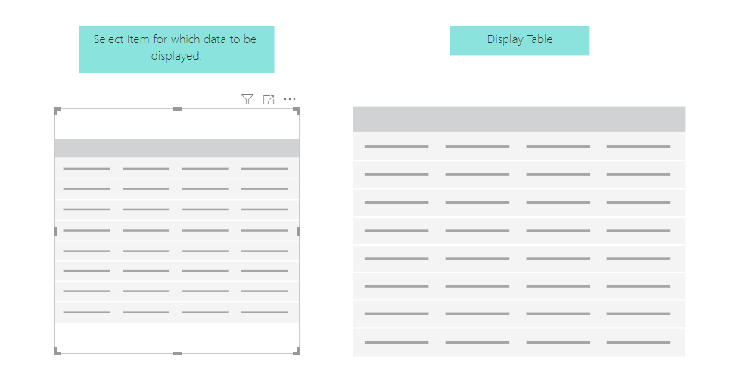

Step 2: In the “Display Table” add the columns that you want to display and in the Filter Table add column field by which  
 you want to filter.

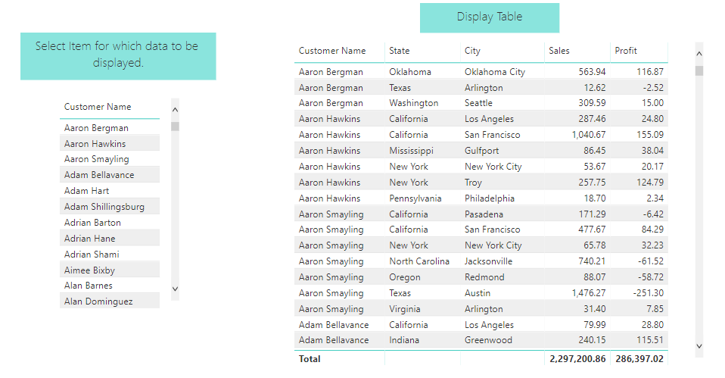

Step 3: Now create a new measure with DAX shown below.



Step 4: Select the “Display table” and add a visual level filter for “SelectedItem” as shown and click on ‘Apply Filter’.

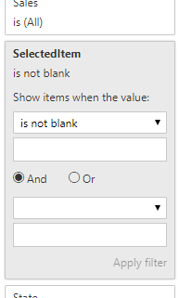

Step 5: After applying the filter, “Display Table” will be empty and if any name is selected in the filter table, only the data  
 for that name will be displayed.

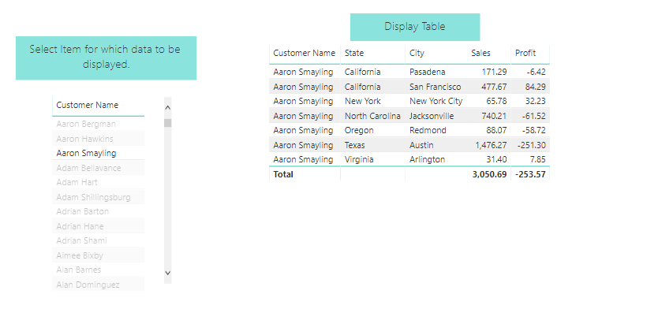

Important Link:

* [Table Visualisations blank until something selected in a slicer](https://community.powerbi.com/t5/Desktop/Table-Visualisations-blank-until-something-selected-in-a-slicer/td-p/572696)